Rose Tree Media School District

Summer 2025 Reading & Math

Entering 5th Grade







Name __________________________



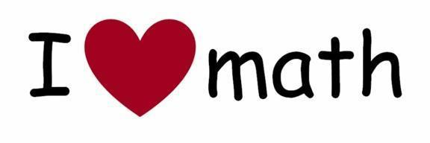

*Summer Math Practice for Rising 5th Graders* - Complete the following tasks throughout the summer. Use scratch paper when needed and copy your answers into your booklet, or use the space given on some handouts to choose your answer, show your work, and/or explain your thinking when needed.

Math Practice - Rising 5th Graders

| **Place Value**  Write the number in expanded form.    42,637 | **Addition/Subtraction**    229 + 171 + 66 + 40 = | **Multiplication/Division**    126 x 8 = |
| --- | --- | --- |
| **Fractions/Decimals**    Shade the figure to show 4/6.     |  |  |  | | --- | --- | --- | |  |  |  | | **Measurement**    Use >, < or =    10 inches _____  1 ft. | **Algebraic Thinking**    20 + 16  =  __ x 3 |
| **Decimal**    $17.46 - $9.78 = | **Addition/Subtraction**    1,214 – 386 = | **Division**    36 ÷ 9  =  12 ÷ ___ |

| **Place Value**     Round this number to the nearest thousand.    1,359,498 | **Addition**    386 + 214 + 63 = | **Division**    1,356 ÷ 6 = |
| --- | --- | --- |
| **Fractions**    Change the improper fraction to a mixed number.  13/6 = | **Measurement**    Use >, < or =    22 inches ___  1 ft. 8 in. | **Algebraic Thinking**    List the first five multiples of 8. |
| **Decimals**    Write  .78 as a fraction. | **Subtraction**    813 – 567 = | **Division**    (45 ÷ 5) x 3 **=** |

| **Place Value**    In the number 412,464, the four in the hundreds place is _________ times more than the 4 in the ones place. | **Addition/Subtraction**    4,126 + 2,015 = | **Multiplication/Division**    12 x 34 = |
| --- | --- | --- |
| **Fractions/Decimals**    Add the following:    2/10 +  3/100 | **Measurement**    Use >, < or =    20 inches _____  2 feet | **Algebraic Thinking**    Write all the factors of 24. |
| **Decimals**    Compare these two numbers using one of these symbols.  > = <    .24  ______  .42 | **Addition/Subtraction**    (56 – 28) + (112 – 73) = | **Multiplication/Division**    (6 x 5) ÷ 3 **=** |

| **Place Value**    Write the word name.    600,000 + 40,000 + 5,000 + 600 + 80 + 9 | **Addition**    100 = 63 + ___ | **Division**    68 ÷ 9 = |
| --- | --- | --- |
| **Fractions**  Find the sum. | **Measurement**    Calculate the elapsed time.    6:35 AM to 9:08 AM | **Algebraic Thinking**    Below is a set of cubes.     | G | Y | G | Y | G | Y | | --- | --- | --- | --- | --- | --- |     What color is the 33rd cube? |
| **Decimals**  Find the sum.    6.13 + 5.08 + 2.7 = | **Subtraction**    Estimate.    79,868 - 41,235 = | **Multiplication**    56 x 8 = |

| **Place Value**  Order from least to greatest.    6,310;   63 hundreds;   6,000 + 300 + 3 | **Addition/Subtraction**                $45.61                23.87            + 11.09 | **Multiplication/Division**    There are 14 baseball teams in East Side Little League.  Each team has 16 players.  How many kids play baseball for East Side Little League? |
| --- | --- | --- |
| **Fractions/Decimals**    Write a fraction that represents the number of circles in the set. | **Measurement**  Choose the best answer.    The amount of milk in your glass.    **Ounces   Gallons** | **Algebraic Thinking**     | Input | 3 | 6 | 9 | 7 | 5 | | --- | --- | --- | --- | --- | --- | | Out-  put | 16 | 34 | 52 |  |  |     Rule: |
| **Fractions/Decimals**  Write the given fraction as a decimal.    4/5 = | **Subtraction**    225 - 45 = _____ | **Division**    $44.00 ÷ 8 = |

**Math Card Games**

If you have a deck of cards, you can play any of these games and practice your math while you’re having fun!

***Go Fish:*** (addition) Use a deck of cards from 0-10 (Take out the face cards and have wild cards be 0 and Aces be 1). Play "Go Fish" to add numbers up to 10. (Ex: Sally has the number 4, so she asks her mother for the number 6 because 4+6=10.)  
 ***War:*** (addition or multiplication)Divide the deck of cards evenly. Each player will put out two cards and add them together. Whoever has the highest sum will take all cards. The object is to take the whole deck.  This can also be done with multiplication.  Whoever has the highest product will take all cards.

***Number Family Rummy:*** (fact families) Use a deck of 40 cards: Four suits of ace through ten. The goal is to make families of three cards that are related by addition or subtraction. For example: 5, 5, and 10 are a family because 5+5=10, and 10-5=5. 6, 3, and 9 are a family because 6+3=9, 9-6=3, and 9-3=6. Shuffle the deck and deal 6 cards to each player. Place the remaining cards face down in a pile. If you have any families of cards, place them aside. If you don't have any families, you may draw one from the pile and discard one of your own. You may also discard the one that you picked up, if you don't want it. The first player to get rid of all 6 cards (2 fact families) is the winner. Remember that the ace equals one.

[***Flip Up***](http://www.flashmaster.com/cgi-bin/redirect.cgi?goto=/multiplication_table.htm&code=MULTIPLICATIONCOM)***:*** (addition or multiplication)  
This game is played by two people with a deck of cards.  Remove the jokers and face cards.  Shuffle the deck and deal the cards face down.  Each player flips over a card from his or her pile.  The first player to call out the correct answer (can be sum or product depending on focus skill) gets to collect the flipped over cards.  If a player calls out the wrong answer the other player gets the cards.  Players continue until all the cards have been flipped over.  The winner is the player with the most cards at the end.

***Make 10:*** (addition)  
Remove the face cards from a deck. Deal 12 cards face up. Players take turns finding and removing combinations of cards that add up to 10. When both the players agree that no more tens are possible, more cards are dealt. This game helps students recognize parts of 10, an important step in learning to add and subtract base 10 numbers.

***Flash:*** (like Headbands) (addition/subtraction or multiplication/division) In this game for three players, one student is the leader and the other two are the players. The two players each draw a card and, without looking at it, hold it up to their foreheads so that everyone else can see it. The leader announces the sum (or product if doing multiplication) of the two cards. Each player must figure out which card is on his or her own forehead. When both players have figured out their cards, a new leader is chosen and the game continues. Try playing this game with four or five players for a challenge!

***Build a Number:*** (multiple operations – similar to the game “24”)  When playing this game with younger children, remove the face cards; with older kids, make Jacks worth 11, Queens 12 and Kings 13. If your deck has Jokers, make them worth 0.

Each group of 2-5 students selects a target number from 1-30. Five cards are then flipped face up, and the object is for students to make a number sentence using all five cards with any operations to reach the target number.

For example, suppose the target number is 20 and the cards in play are 5, 5, 6, 2, and Ace (worth 1). One winning combination is: 5 x 2 + 5 + 6 - 1 = 20. Another is (6 x 5) - (2 x 5 x 1). Also, (6 ÷ 2) x 5 + (5 x 1) works, as do many more.

The first player to find a winning combination keeps the cards and chooses the next target number. If no combination is found in about a minute, flip over another card and try to make a combination using six cards.

To keep the game fair for players of different abilities, introduce the rule that if a player hasn't made a combination in three rounds, he or she may make combinations using four of the five cards; other players must use five.

***Multiplication Zone:*** (multiplication and estimation)  
This game for two to four players encourages the use of multiplication facts and estimation. Jacks are worth 11, Queens 12 and Kings 0 or 13. Each player is dealt 10 cards.

A card from the remaining stack is flipped face up. Its value is multiplied by 10, and players try to find a pair of cards whose product is in that "decade." For example, if the flipped card is a six, then the zone is any number in the sixties (60-69), so a winning pair would be 9 and 7 (product 63) or 12 and 5 (product 60), etc.

Any player who can make a pair removes those cards from his or her hand. Play continues until one player's hand is empty.

**Math Facts Goals Sheet**

Directions: Fill in one square every time you practice your math facts for at least 5 minutes.

|  |  |  |  |  |
| --- | --- | --- | --- | --- |
|  |  |  |  |  |
|  |  |  |  |  |
|  |  |  |  |  |
|  |  |  |  |  |

**Math Facts Practice Chart**

Directions: Write your initials in one circle every day that you practice math facts.

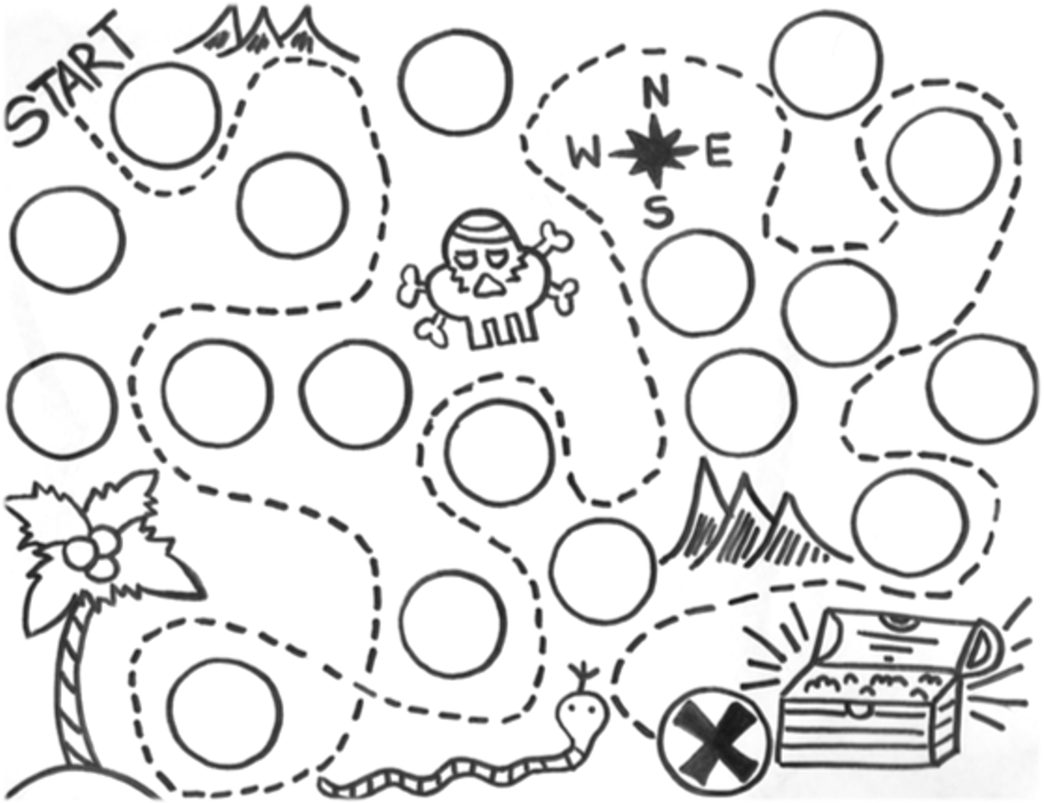



**12 Fun Ways to Practice Math Facts**

**1. Ask your child math facts**

Ask your child math facts as you are making dinner or riding in the car.

**2. Roll the Dice**

Borrow the dice from your favorite board game. Practice adding, subtracting, multiplying or dividing the amounts on its faces.

**3. Play** [**Math Bingo**](https://www.pinterest.com/search/pins/?q=math%20bingo&rs=typed&term_meta%5b%5d=math%7Ctyped&term_meta%5b%5d=bingo%7Ctyped)**.**

Make up your own board. Use math fact cards to see if you can get Bingo!

**4, Get Hands-on**

Use items like Cheerios, marbles, or pencils. Put them in small groups and count them.

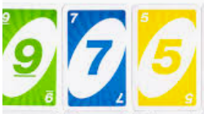

**5. Use Cards**

Use cards from your Uno or Go Fish games.  Add, subtract or multiply them.

**6. Race to 100**

Borrow a set of dice from another game. Roll the dice, then add or multiply the numbers. Record your score. The first person to get

to a predetermined number, like 100, wins.

**8. Create a Math Concentration Memory game.**

Use math facts cards or make your own with index cards. Place the cards down. Each player turns over two cards to see if there is

a match.

9.  **Skip Counting**

Counting by 2s, 5s, 10s, and so on can be fun to do together as your child hears patterns in numbers. You can also show the

skipping on a hundred chart. 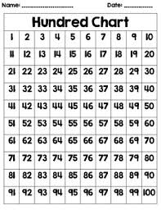

### 10. Math Toss

Toss a balloon or ball around the room with your child. As you toss, call out a math fact. The goal is for him to call out the answer

before passing it on.

### 11. Fact of the Day

If your child is having difficulty with just a few facts, choose one of them at a time and make it the “fact of the day.” Post the fact in a

place where it will be seen often. Then ask your child frequently during the day to tell you the answer.

12. **Dominoes Fun** - Each pair gets 20 dominoes. Turn over two at a time. Add, subtract or multiply the dots. The person with the

higher number gets to keep all four dominoes.  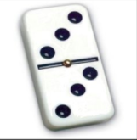

Get to Zero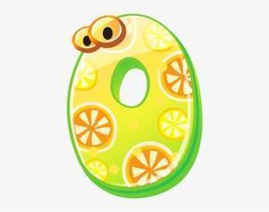

This game provides students practice subtracting from 999.

**Materials:**

* Three dice
* Paper and pencil

**Game instructions:**

1. On a sheet of paper, each player needs to write his or her names and the number 999 under them.

2. A player rolls the three dice, then arranges the three numbers is some order and subtracts that 3-digit number from 999 (for example, 235, 352, 532 and so on). The other players should also check the player’s work.

3. The players take turns rolling the die to make their special number and subtracting that number from their total.

4. The winner is the first player to reach 0, but they must get to 0 exactly!

**Note:**  At any time, a player may choose to roll only one or two dice instead of three dice. If the only numbers a player can make are larger than his remaining score, the player loses this turn.

* Activity from <https://www.youcubed.org/tasks/get-to-zero/>

Summer Reading

Family Resources and Reading Log



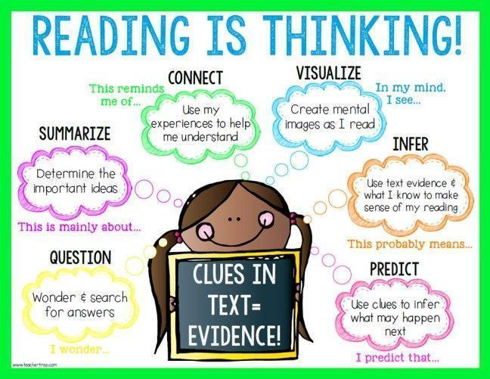

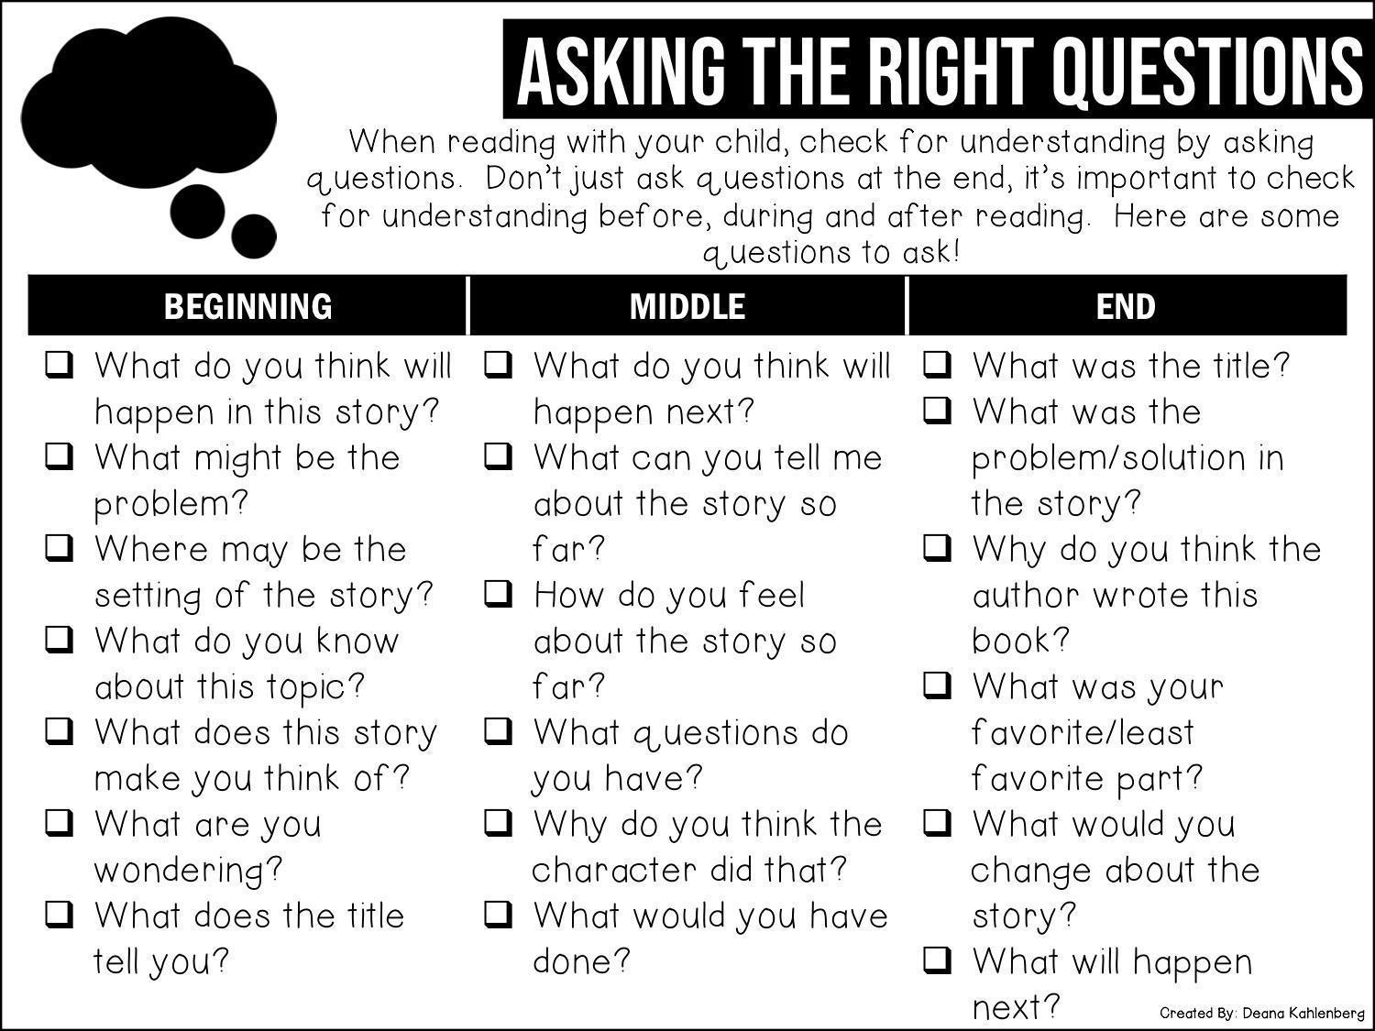

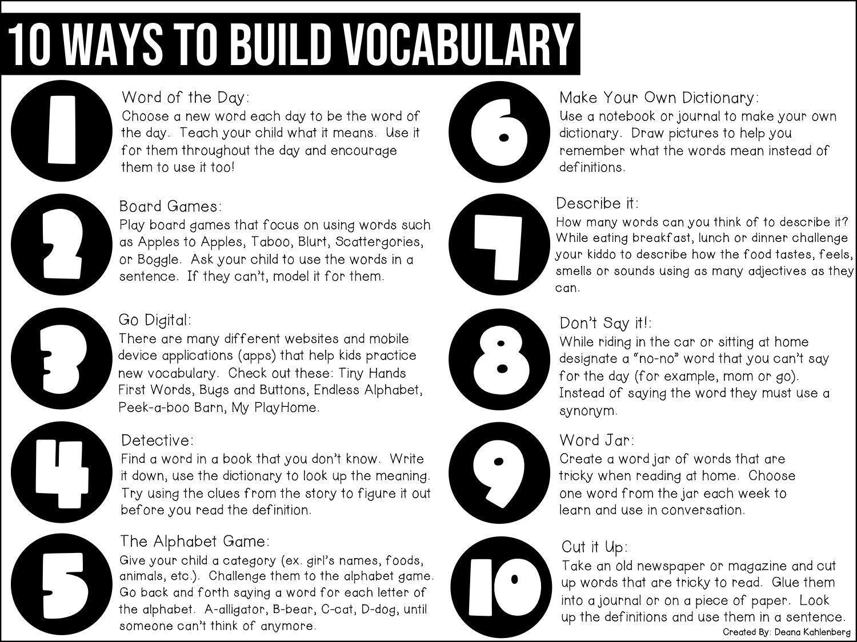

Directions: During the months of June, July, and August, cross off or color in a square each time you give one of the following reading suggestions a try. How many times can you get “five in a row”? Can you fill the entire board?

**June 2025**

| **Read outside.** | **Read a book**  **with a number in the title.**  **2 4 9 3 5** | **Read a book written by a favorite author.** | **Read to a pet.** | **Read while listening to music.** |
| --- | --- | --- | --- | --- |
| **Read while**  **it’s raining.** | **Read with sunglasses on.** | **Read in a bathtub.** | **Read a mystery.** | **Read a book with an animal on the cover.** |
| **Your choice!** | **Read in the dark with a flashlight.** | **Read under**  **a table.** | **Read while eating a snack.** | **Read while**  **lying down.** |
| **Read a fantasy story.** | **Read a book of jokes or riddles.** | **Read while wearing a hat.** | **Read with**  **a friend.** | **Read a book that is humorous.** |
| **Read with a stuffed animal.** | **Read with someone you love.** | **Read with**  **an accent.** | **Your choice!.** | **Read a book**  **with a name in the title.** |

** July 2025 **

| **Read a scary or suspenseful book.** | **Read a book**  **that has the word “the” in**  **the title.** | **Read a book**  **in a series.** | **Read with someone older than you.** | **Build a fort and read inside.** |
| --- | --- | --- | --- | --- |
| **Read while eating fruit.** | **Read with a stuffed animal.** | **Read while sitting under a tree.** | **Your choice!** | **Read a book recommended to you by a friend.** |
| **Read while wearing red, white, and blue.** | **Read a**  **biography.** | **Read with a family member.** | **Read right before you fall asleep.** | **Record yourself reading aloud.** |
| **Read a book that has a child as a main character.** | **Read a book on Zoom with a friend or family member.** | **Read while eating breakfast.** | **Read while sitting backwards on a chair.** | **Read a book involving sports.** |
| **Read in bed.** | **Your choice!** | **Read in the dark with a flashlight.** | **Read while having a picnic.** | **Read on**  **a couch.** |

** August 2025 **

| **Read in your pajamas.** | **Read a book by an author you’ve never read before.** | **Your choice!** | **Read while**  **eating ice cream.** | **Read a story**  **that took place long ago.** |
| --- | --- | --- | --- | --- |
| **Read at a park.** | **Read a magazine or news article.** | **Read a book that makes you laugh.** | **Read some**  **poems.** | **Read with someone younger than you.** |
| **Read a book you loved when you were little.** | **Read with a whisper voice.** | **Read with a stuffed animal.** | **Read while enjoying a drink.** | **Read when you first wake up.** |
| **Read in your mom or dad’s bed.** | **Read an entire book in one sitting.** | **Read like a storyteller.** | **Read to a pet.** | **Hold a spoon and pretend to read into it like a microphone.** |
| **Read in**  **the shade.** | **Read an adventure book.** | **Read two chapters.** | **Read under an umbrella.** | **Your choice!** |

**HOW TO GET BOOKS...FROM HOME!**

If you don’t have a library card, get one here: <https://charlotte.delco.lib.pa.us/selfreg>!

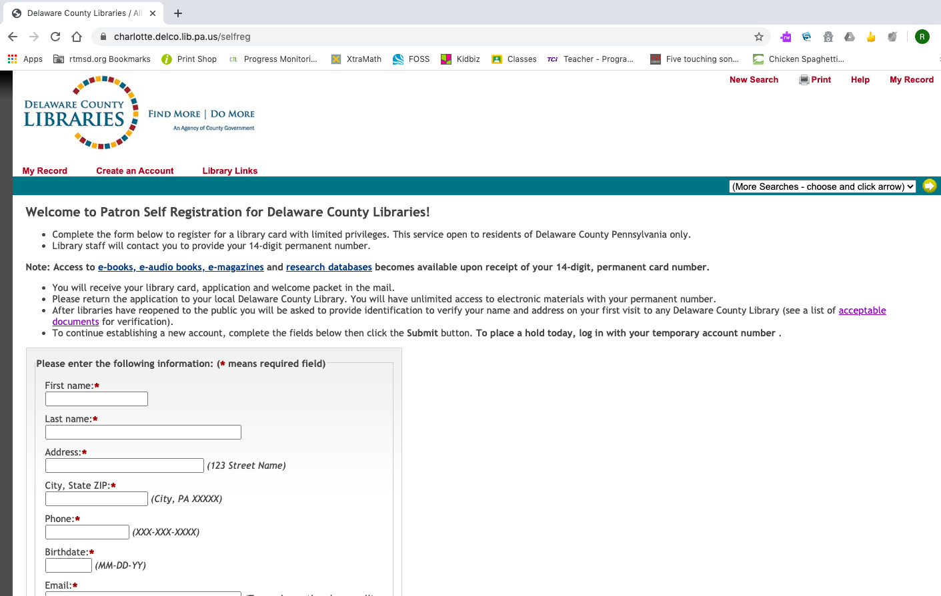

In order for free access with a DCLS library card, patrons have to go through the [www.delcolibraries.org](http://www.delcolibraries.org/) website.

-->Click Explore Resources.

-->Scroll through the resources & click on the ones of interest.

Our highest recommendations for sites to get books are:

[BookFlix](https://e-resources.powerlibrary.org/ext/econtent/BarcodeEntry/index.php?lid=PL3410R&dataid=1162&libname=DELAWARE+COUNTY+LIBRARY+SYSTEM)

Hoopla

[TrueFlix](https://e-resources.powerlibrary.org/ext/econtent/BarcodeEntry/index.php?lid=PL3410R&dataid=2100&libname=DELAWARE+COUNTY+LIBRARY+SYSTEM)

[Tumblebooks](https://charlotte.delco.lib.pa.us/wamvalidate?url=http%3A%2F%2F0-www.tumblebooks.com.charlotte.delco.lib.pa.us%3A80%2Flibrary%2Fauto_login.asp%3FU%3Ddelawarecopl%26P%3Dlibra)

[Virtual Storytime](http://www.delcolibraries.org/Virtual-Storytime)

[World Almanac for Kids](https://charlotte.delco.lib.pa.us/wamvalidate?url=https%3A%2F%2F0-online-infobaselearning-com.charlotte.delco.lib.pa.us%3A443%2FDirect.aspx%3Faid%3D10305%26pid%3DWAKE)

[NoveList K-8](https://charlotte.delco.lib.pa.us/wamvalidate?url=http%3A%2F%2F0-search.ebscohost.com.charlotte.delco.lib.pa.us%3A80%2Flogin.aspx%3Fauthtype%3Dip%252Curl%252Ccustuid%26custid%3Ds5529982%26profile%3Dnovelistk8) - book lists & reviews

Summer Reading Log

Log the minutes you read.

| **Minutes** | **Date** | **Book Title** | **Adult Initials** |
| --- | --- | --- | --- |
|  |  |  |  |
|  |  |  |  |
|  |  |  |  |
|  |  |  |  |
|  |  |  |  |
|  |  |  |  |
|  |  |  |  |
|  |  |  |  |
|  |  |  |  |
|  |  |  |  |

Log the minutes you read.

| **Minutes** | **Date** | **Book Title** | **Adult Initials** |
| --- | --- | --- | --- |
|  |  |  |  |
|  |  |  |  |
|  |  |  |  |
|  |  |  |  |
|  |  |  |  |
|  |  |  |  |
|  |  |  |  |
|  |  |  |  |
|  |  |  |  |
|  |  |  |  |

Log the minutes you read.

| **Minutes** | **Date** | **Book Title** | **Adult Initials** |
| --- | --- | --- | --- |
|  |  |  |  |
|  |  |  |  |
|  |  |  |  |
|  |  |  |  |
|  |  |  |  |
|  |  |  |  |
|  |  |  |  |
|  |  |  |  |
|  |  |  |  |
|  |  |  |  |

Log the minutes you read.

| **Minutes** | **Date** | **Book Title** | **Adult Initials** |
| --- | --- | --- | --- |
|  |  |  |  |
|  |  |  |  |
|  |  |  |  |
|  |  |  |  |
|  |  |  |  |
|  |  |  |  |
|  |  |  |  |
|  |  |  |  |
|  |  |  |  |
|  |  |  |  |

Log the minutes you read.

| **Minutes** | **Date** | **Book Title** | **Adult Initials** |
| --- | --- | --- | --- |
|  |  |  |  |
|  |  |  |  |
|  |  |  |  |
|  |  |  |  |
|  |  |  |  |
|  |  |  |  |
|  |  |  |  |
|  |  |  |  |
|  |  |  |  |
|  |  |  |  |

Log the minutes you read.

| **Minutes** | **Date** | **Book Title** | **Adult Initials** |
| --- | --- | --- | --- |
|  |  |  |  |
|  |  |  |  |
|  |  |  |  |
|  |  |  |  |
|  |  |  |  |
|  |  |  |  |
|  |  |  |  |
|  |  |  |  |
|  |  |  |  |
|  |  |  |  |

Log the minutes you read.

| **Minutes** | **Date** | **Book Title** | **Adult Initials** |
| --- | --- | --- | --- |
|  |  |  |  |
|  |  |  |  |
|  |  |  |  |
|  |  |  |  |
|  |  |  |  |
|  |  |  |  |
|  |  |  |  |
|  |  |  |  |
|  |  |  |  |
|  |  |  |  |

Log the minutes you read.

| **Minutes** | **Date** | **Book Title** | **Adult Initials** |
| --- | --- | --- | --- |
|  |  |  |  |
|  |  |  |  |
|  |  |  |  |
|  |  |  |  |
|  |  |  |  |
|  |  |  |  |
|  |  |  |  |
|  |  |  |  |
|  |  |  |  |
|  |  |  |  |

Congratulations!

You are a

Math and

Reading



**Champion!**